Project 6

Animation Demonstration
Make a new directory called Project6 to be used to save a new form and project called animation.frm and animation.vbp respectively.
Create a new form so that it looks like the diagram below (the line is drawn using the line control from the toolbox).
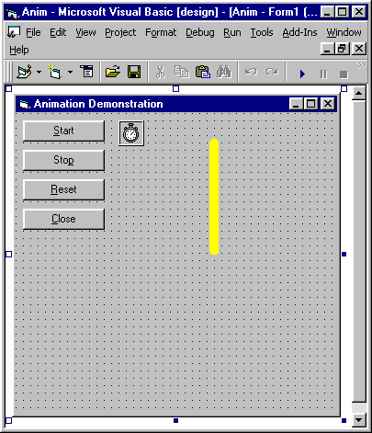
Set the properties as shown on the following pages. As with Project 3 not all of the properties can be accessed, so only set those that you can access.
Before coding the sub procedures examine the attached code and try to determine what will happen at run time (ask if you are not sure). Once you are happy with what you think will happen code the sub procedures.
Run the program and check how it functions. Does it do what you expected?
Up to now you have operated command buttons by pointing the mouse and clicking. There are two others of operating a command button.
When you run the program you will notice that the start command button has a dotted box superimposed on it. Each time you press the Tab on the keyboard you will notice that this box moves from on control to another. The order in which this is done is indicated by the tab index property in the properties window. A control can be activated when it is selected using the Tab key, by pressing Enter on the keyboard (try this).
Also, when you run the program you will notice that one letter in each of the command buttons captions are underlined. Examine the properties window to see if you can determine how this line was introduced. To activate a command button hold the Alt key down and press the keyboard letter that is underlined on the command button. For example for the Start button use Alt S.
Produce a printout of your form, form text and code.
Now it is time to modify your application. If you have ideas of your own try them or ask the lecturer for suggestions. One suggestion would be to make the line rotate backward or turn the program into a full stop watch. Add more comments to your code as required.
Produce a printout of the new form, form text and code.

Code listing (including form as text).
VERSION 5.00
Begin VB.Form Form1
Caption = "Animation Demonstration"
ClientHeight = 4905
ClientLeft = 495
ClientTop = 345
ClientWidth = 5250
LinkTopic = "Form1"
ScaleHeight = 6969.689
ScaleMode = 0 'User
ScaleWidth = 5250
Begin VB.Timer tmrRotate
Interval = 100
Left = 1680
Top = 120
End
Begin VB.CommandButton CmdClose
Caption = "&Close"
Height = 352
Left = 120
TabIndex = 3
Top = 1560
Width = 1335
End
Begin VB.CommandButton CmdReset
Caption = "&Reset"
Height = 352
Left = 120
TabIndex = 2
Top = 1080
Width = 1335
End
Begin VB.CommandButton CmdStop
Caption = "Sto&p"
Height = 352
Left = 120
TabIndex = 1
Top = 600
Width = 1335
End
Begin VB.CommandButton CmdStart
Caption = "&Start"
Height = 352
Left = 120
TabIndex = 0
Top = 120
Width = 1335
End
Begin VB.Line LneRotate
BorderColor = &H0000FFFF&
BorderWidth = 10
X1 = 3240
X2 = 3240
Y1 = 682.049
Y2 = 3181.475
End
End
Attribute VB_Name = "Form1"
Attribute VB_GlobalNameSpace = False
Attribute VB_Creatable = False
Attribute VB_PredeclaredId = True
Attribute VB_Exposed = False
Dim Counter As Integer
Private Sub CmdClose_Click()
End
End Sub
Private Sub CmdReset_Click()
LneRotate.X1 = LneRotate.X2
LneRotate.Y1 = LneRotate.Y2 - 2500
Counter = 1
End Sub
Private Sub CmdStart_Click()
tmrRotate.Enabled = True
End Sub
Private Sub CmdStop_Click()
tmrRotate.Enabled = False
End Sub
Private Sub Form_Load()
Counter = 1
tmrRotate.Enabled = False
End Sub
Private Sub tmrRotate_Timer()
Select Case Counter
Case 0
LneRotate.X1 = LneRotate.X2
LneRotate.Y1 = LneRotate.Y2 - 2500
Case 1
LneRotate.X1 = LneRotate.X2 + 1750
LneRotate.Y1 = LneRotate.Y2 - 1750
Case 2
LneRotate.X1 = LneRotate.X2 + 2500
LneRotate.Y1 = LneRotate.Y2
Case 3
LneRotate.X1 = LneRotate.X2 + 1750
LneRotate.Y1 = LneRotate.Y2 + 1750
Case 4
LneRotate.X1 = LneRotate.X2
LneRotate.Y1 = LneRotate.Y2 + 2500
Case 5
LneRotate.X1 = LneRotate.X2 - 1750
LneRotate.Y1 = LneRotate.Y2 + 1750
Case 6
LneRotate.X1 = LneRotate.X2 - 2500
LneRotate.Y1 = LneRotate.Y2
Case 7
LneRotate.X1 = LneRotate.X2 - 1750
LneRotate.Y1 = LneRotate.Y2 - 1750
End Select

Counter = Counter + 1
If Counter > 7 Then Counter = 0
End Sub

